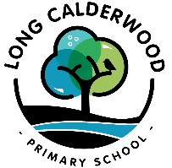
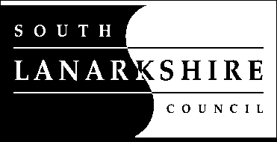

Long Calderwood Primary School

Free School Meals Covid-19 Update – 9th December 2020

South Lanarkshire Council are pleased to announce some new financial supports for families who have children or young people in school entitled to Free School Meals. This does not include those entitled to universal provision of P1-3 meals.

- Winter Fuel Payment

South Lanarkshire Council has approved a scheme to make a one-off payment of £50 to support with winter fuel costs, for families of pupils entitled to free school meals. This does not include those entitled to universal provision of P1-3 meals.

- £100 Winter Payment

South Lanarkshire Council has approved a scheme to make a one-off payment of £100 to families of pupils entitled to free school meals to support with winter costs such as Christmas presents, food, fuel and other essentials. This does not include those entitled to universal provision of P1-3 meals. This payment is per child; families will receive £100 for each eligible child.

- Free School Meals Payment for Pupils Self-isolating

South Lanarkshire Council has approved a scheme to make a one-off payment of £30 to parents/carers towards the cost of lunch for pupils eligible for free school meals but unable to attend school due to requiring to self-isolate as part of the Test and Protect Scheme. This does not include those entitled to universal provision of P1-3 meals.

- Free School Meals Payments During School Holiday Periods

The Scottish Government have provided Local Authorities additional funding for pupils currently in receipt of Free School Meals (this does not include those entitled to universal provision of P1-3 meals), to receive a free school meal payment for the following school holiday periods:

Christmas 2020 One-off payment of £30
February 2021 Mid Term Break One-off payment of £9
Spring Break 2021 One-off payment of £33

- Free School Meals Payment for Pupils Shielding During Tier 4 Lockdown Period

Any pupils eligible for free school meals and in receipt of a letter from the Chief Medical Officer advising they should not attend school and should shield for the 3 week period from Monday 23rd November 2020 to Friday 11th December will receive a one-off free school meals payment of £45 if they actually shield and do not attend school. This does not include those entitled to universal provision of P1-3 meals.

- £500 Self-isolation Support Grant

From 7th December the Scottish Government is giving a £500 Self Isolation Support grant to families if they are:

- The primary carer or parent of a child who has been asked to self-isolate by Test and Protect or the school AND
- They receive low income benefits AND
- Are employed or self-employed and will experience reduced earnings because you have to stay at home to look after your child.

More information, including information on eligibility and how you can apply for this self-isolation grant can be found on the SLC website.

The SLC Website contains more detailed information for parents/carers including information on eligibility, how this will be paid and a Frequently Asked Questions section. Please refer to this information in the first instance.

