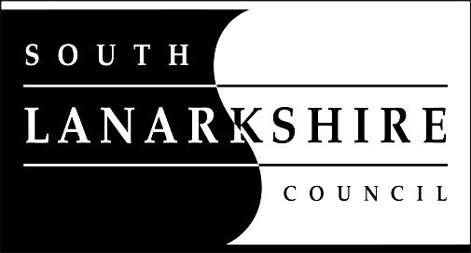

Education Resources

Privacy Notice
Introduction
In line with the General Data Protection Regulation (GDPR) we have produced this privacy notice to inform you how we deal with personal information as part of our statutory function as an education authority.

The Council has a legal obligation to deliver effective education services to children, young people and adult learners in South Lanarkshire. In order to do this we need to collect personal information about children, young people and their families so that we can help them to learn and keep them safe.

Using your personal information
The Council is a “controller” of the personal information you provide when enrolling for a nursery or school, applying for an education service or participating in groups or activities provided by Education Resources.

Information we collect from you about you and your child at enrolment
When you enrol for a nursery or school, we ask for the following information:
- parent/carer contact details (name, address, phone, email);
- the child’s name, date of birth, gender and address;
- information about medical conditions, additional support needs, religion and ethnicity;
- any information you may wish to provide about family circumstances.

Information we collect at other times
We will also collect information at other times such as when you apply for a benefit, request a services or other support. We will provide an additional privacy notice at these times.
- If you apply for an education service or benefit, such as school transport, free school meals, clothing grant, placing request or EMA, we will also ask for personal information as set out above. We will also ask for information about your income for education benefits applications.

- If you make a request for additional support such as an educational psychologist or other support for learning we will ask for more detailed information to allow us to provide the most appropriate support for your family. This may include information about family circumstances or medical conditions.

- If there are concerns about your child’s wellbeing and/or your child has needs that may require additional support, we will wish to work with you to collect and consider information to enable us to help you get the right support at the right time in line with the Getting it right for every child approach.

We require this information to ensure that children and young people are educated appropriately, supported, and that we take account of their health and wellbeing. We will also ask you to update this information annually and to tell us when there are changes to your details.

Information that we collect from other sources
As an education authority and as part of our statutory function in accordance with our legal obligations, we receive information from other sources such as the SQA, the NHS or Social Work about you or your child, this includes:
- exam results and assessment information;
- information about health, wellbeing or child protection.

Why do we need this information?
We need this information so the Council can ensure it is delivering education services appropriately to all learners:
- for the education of children, young people and adult learners;
- for teaching, enrolment and assessment purposes and to monitor the educational progress of children, young people and adult learners ;
- to keep children and young people safe and provide guidance services in school;
- to identify where additional support is needed to help children, young people and adult learners with their learning;
- to maintain records of attendance, absence and behaviour of children and young people (including exclusions);
- to support children and young people moving on each year from nursery to primary, primary to secondary and when they move or leave school;
- to help us develop and improve education services provided for young people, adult learners or families
- In accordance with our legitimate interests as an education authority we will also use your information to create statistical reports.

We will share your information with:
As an education authority and as part of our statutory function in accordance with our legal obligations we will share information with other bodies or parts of the Council, including:
- The Scottish Government and bodies such as Education Scotland, Scottish Qualifications Authority, Skills Development Scotland and other organisations that support children and young people’s learning;
- Other parts of the Council when required for services such as school meals, school transport, education benefits and with Social work in connection with any child protection concerns we become aware of;
- The NHS, to support health initiatives in accordance with the legal obligation on the Council in terms of section 39(3) of the National Health Service (Scotland Act 1978;
- South Lanarkshire Leisure and Culture Limited, where children and young people are participating in sports and leisure activities;
- Other schools/local authorities – if a child moves or transfers to another school the Council has an obligation to pass on information with regards to pupil records to the new school/local authority.

You have the right to access your personal information as well as the rights of rectification, erasure, restriction and the right to object. For information on these rights and how to exercise them or for information about how we manage your personal information, you can get a copy of our full privacy notice from our website: (https://www.southlanarkshire.gov.uk/info/200235/meta/1730/general_privacy).

Our full privacy notice will also provide information on how to make a complaint or to request a paper copy of the privacy notice from the Data Protection Officer.
Version 3: December 2019

